**INHEAL: Innovation in   
Health Literacy**

National Analysis in Slovakia,   
English Version.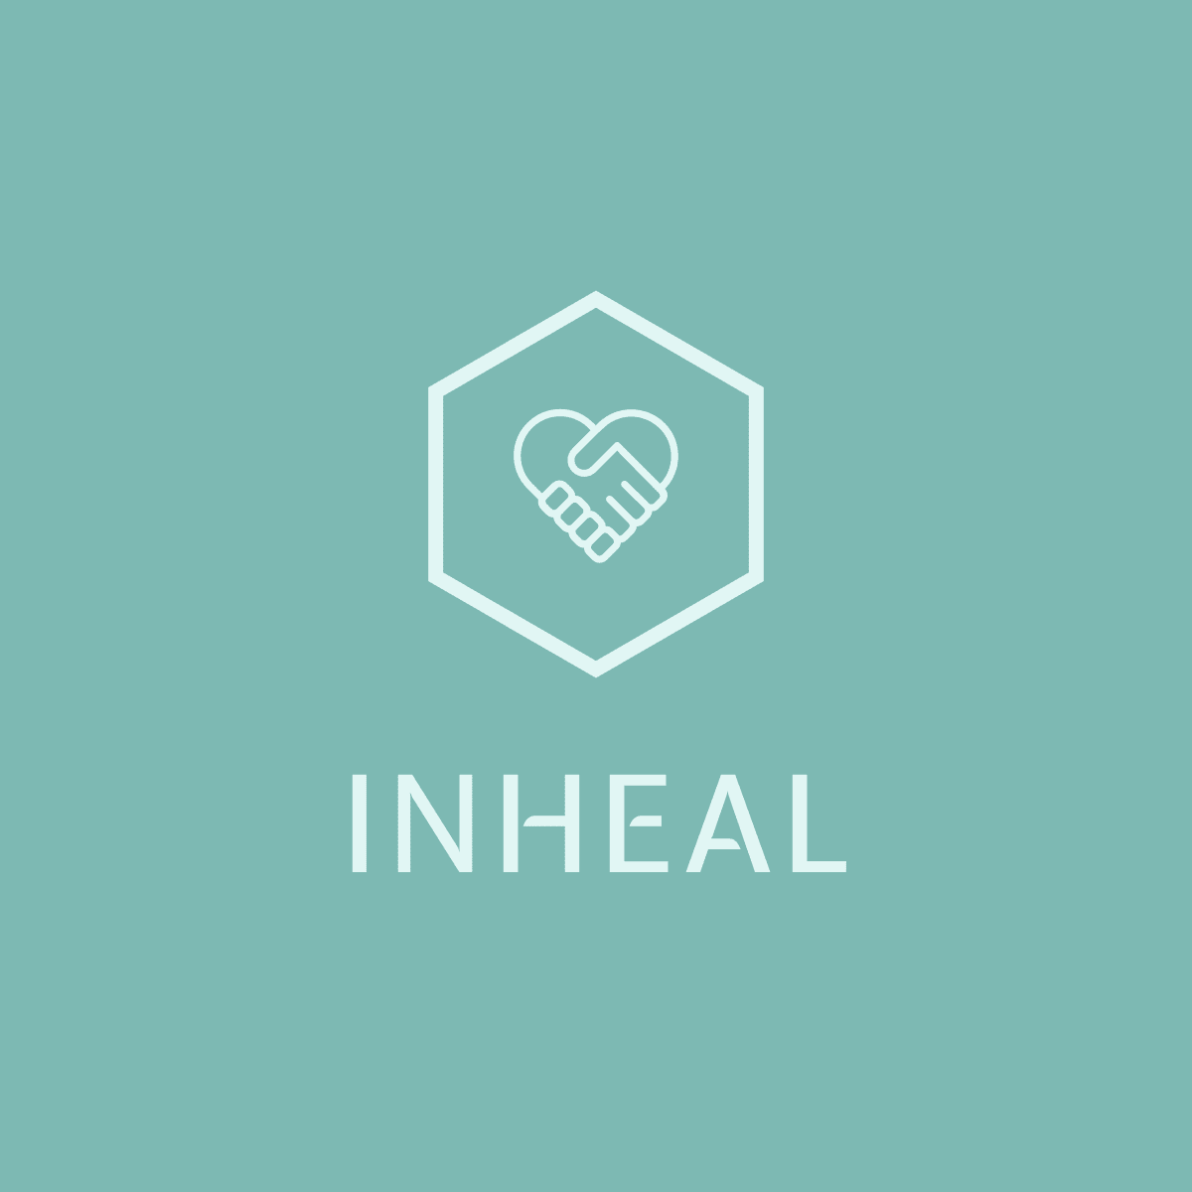

**INHEAL: Innovation in Health Literacy**

**Deliverable 1: Analysis  
Desk research: Slovakia, April 2022**

*The project is co-financed by the Governments of Czechia, Hungary, Poland, and Slovakia through Visegrad Grants from International Visegrad Fund. The mission of the fund is to advance ideas for sustainable regional cooperation in Central Europe.*

| INHEAL: Innovation in Health Literacy | |
| --- | --- |
| Deliverable 1: Analysis - Country desk research | |
| Identifier | PJ Safarik University, Faculty of Medicine  Faculty of Medicine, Dept of Social and Behavioural Medicine  Zuzana Katreniakova, Marta Nemcikova, Iveta Nagyova |
| Time horizon | Specific focus on 2015-2022. |
| Research objectives | Research objectives of desk research performed in Slovakia were following:   * To identify the real, relevant gaps and seniors’ learning needs (knowledge and skills) of accessing health information and services including special focus on the use of ICT based methods; * To determine the current state of play measures and practices adopted at the national, regional or local levels to enhance accessing (digital) health information and services. |
| Research items | In Slovakia, a desk research was realized between March 10 and April 10, 2022. The search for relevant literature sources was done by using the combination of words such as:   * seniori/starší ľudia (seniors/older people) * (digital) zdravotná gramotnosť ((digital health literacy) * vedomosti/zručnosti (knowledge/skills) * starnutie (aging) * intervencia (intervention) * zdravie/COVID-19 (health/COVID-19)   Out of 58 found documents, 11 were excluded from further analysis (5 due to the date of its publication outside the agreed period 2015-2022 and 6 due to its focus on different target group e.g. adolescents, youth adults, adult population in general). Table 1 presents a short overview on the selected characteristics of **47 documents included in the continuous content analysis**.  Table 1 Selected characteristics of documents (N=47) used for the content analysis in Slovakia   |  | | n | % | | --- | --- | --- | --- | | Type of document | EB guides | 2 | 4.3 | |  | National strategic documents | 10 | 21.3 | |  | European/global reports | 5 | 10.6 | |  | National reports | 8 | 17.0 | |  | Research papers | 15 | 31.9 | |  | Professional papers/textbooks | 3 | 6.4 | |  | Students’ final work | 3 | 6.4 | | Language of document | Slovak | 33 | 70.2 | |  | Czech | 1 | 2.1 | |  | English | 13 | 27.7 |  1. **National Context of Health Literacy among Senior Citizens**  * Health Literacy definition, general characteristics * National Health Literacy studies overview: evolution of health literacy assessment tools and measuring methods, trends across years, and status quo, special focus on senior citizens * National Health Literacy statistics: health literacy levels among seniors across years and status quo; main gaps and issues identified by the latest studies (i.e. individual and system factors) * National Strategy Path on Diseases Prevention, Health Protection, and Health Promotion: Priority Areas and Strategic Objectives * Existing and Developing Public Policies for increasing Health Literacy, special focus on their scope of action and impact on senior citizens’  1. **National Context of Digital Health Literacy among Senior Citizens**  * Broad scope of Digital Health (categories of tools and services) * Digital Health Literacy definition, general characteristics * National statistics on ICT use: current number of households having access to the Internet, equipped with a computer, landlines, mobile lines, measured popularity of e-health resources, special focus on seniors * National Digital Health Literacy overview: health literacy levels among seniors across years and status quo; main gaps and issues identified by the latest studies (i.e. individual and system factors) * National promotion and use of ICT tools and techniques in accessing health information and services, general support policies * National current trends/methods/approaches targeting seniors in relation to improving their digital health literacy level, focus on good practices and transferable trends/current methods |

| **Research body** |
| --- |

In Slovakia, the proportion of people aged 65 years old or more is projected to expand from 16.0 % in 2019 to 20.9 % in 2030. Between 2019 and 2050, the proportion of people aged 65 and over will increase by 13.4 %, reaching 29.4 % in 2050. Furthermore, Slovakia belongs to the EU-27 countries with a significant **gender imbalance for very old people**. It is most apparent among people aged 85 years old or more. In 2018, there were more than 2.5 women aged 85 and over for every man in the same age group. A large gap was also recorded for people aged 75-84 years with approximately 1.8 women per man in this age range (EC, 2021, pp. 382-383).

The expected demographical development will bring many significant challenges. Society must be ready for an increasing number of people in older age, integration of a higher number of foreigners, and increased tension in intergenerational relations. To handle the situation, the new approaches to population, family, social, economic and migration policies are necessary. Due to the unfavourable demographical development in Slovakia, it is assumed, in the medium-term horizon, a significant increase in healthcare services demand, mainly in the field of elderly care. To estimate the public expenditure increase in the health sector in correlation with demography, several scenarios have been prepared, of which the “reference scenario” may be considered the most realistic one (Graph 1). Based on the assumption that a half of years of increased life expectancy will be spent in impaired health condition, and at the same time, it also includes scenario of impact of income elasticity on healthcare services demand (Vláda SR, 2013, pp. 18-20).

Graph 1 Growth of public health care spending in the period of 2010-2060 (in % of GDP)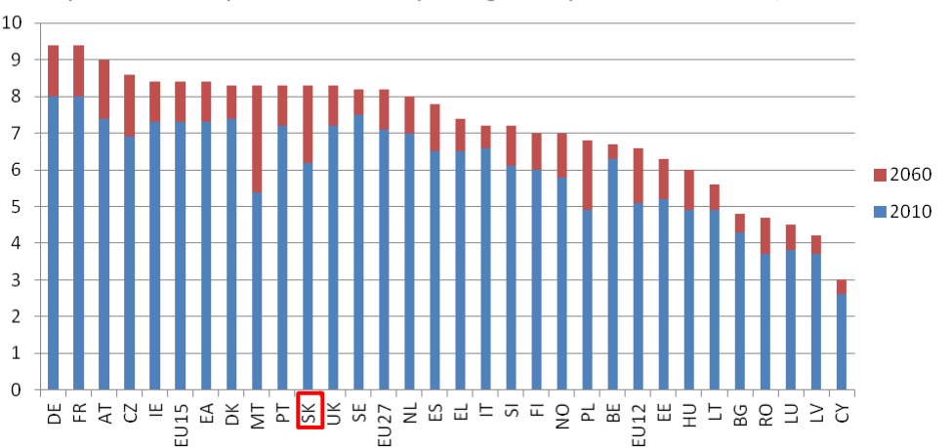

Source: Vláda SR. (2013).

Furthermore, these demographic trends, combined with the perspective that (digital) health literacy in general declines with the age (Janura, 2018, p. 133), point to the meaningful need to identify the relevant gaps and seniors’ learning needs as well as to determine the current state of play measures and practices adopted to enhance accessing (digital) health information and services.

**I. National Context of Health Literacy among Senior Citizens**

* **Health Literacy definition, general characteristics**

In Slovakia, the WHO definition (1998) which defines **health literacy (HL)** as “the cognitive and social skills which determine the motivation and ability of individuals to gain access to, understand and use information in ways which promote and maintain good health”, is considered one of the most influential of the existing definitions of health literacy (Dimunová, 2018b; Hulková, 2018; Kolarcik et al, 2017; Novysedláková & Hudáková, 2012). However, also other definitions are presented e.g. HL is a measure of an individual's ability to obtain, process and understand the basic health information needed to make adequate health decisions. It includes the ability to functionally and effectively interpret and use written text and numbers as skills that may seem different but highly correlated with each other (Beňadiková & Bóriková, 2021).

The key prerequisites for HL are reading literacy and elementary knowledge of mathematics (EESC, 2019), which are currently considered “basic skills” (literacy) together with knowledge of the Slovak language, digital and media literacy (MŠVVaŠ SR, 2021, p. 22). **Reading literacy** is defined as the ability to understand and know how to use a written text, to assess its meaning and to engage in social life through a written text, to achieve goals and to develop one's abilities and personal preconditions. **Mathematical literacy** is defined as the ability to acquire, use, interpret and communicate mathematical information and concepts in solving mathematical questions in various situations of everyday life. Mathematically literate is one who responds correctly to the mathematical content, information, and concepts encountered in the various contexts of everyday life. Because fulfilling a mathematical problem depends in part on the ability to read and understand a text, mathematical literacy requires more than just applying numeracy skills, it must apply them in relation to information that is part of a larger text (Bunčák et al, 2013).

* **Health Literacy studies overview**

*Evolution of health literacy assessment tools and measuring methods*

During the last 7 years, several assessment tools and measuring methods were presented, but only some of them were also used to measure the HL among adult population in Slovakia.

In 2014-2015, Slovak version of the **Health Literacy Questionnaire** (HLQ, Osborne, Batterham et al. 2013) was prepared and used. It is a comprehensive measurement tool that focuses on nine different areas: 1. Feeling understood and supported by healthcare providers; 2. Having sufficient information to manage my health; 3. Actively managing my health; 4. Social support for health; 5. Appraisal of health information; 6. Ability to actively engage with healthcare providers; 7. Navigating the healthcare system; 8. Ability to find good health information; and 9. Understanding health information well enough to know what to do. The HLQ characterizes the manifestations of low and high level for each area, which enables the creation of a detailed profile of the respondent's health literacy and the identification of problematic areas to which it is appropriate to target recommendations or interventions aimed at improving health literacy. The HLQ is considered a basic tool for developing interventions in the field of effective management of chronic diseases (Čepová, 2017; Cepova et al, 2018). It identifies the HL strengths and limitations of individual people rather than trying to categorize them as having “low” or “high” HL (Kolarcik et al, 2017).

In 2019-2020, two Slovak short forms (HLS19-Q12 and HLS19-Q16) adapted from the original **European Health Literacy Survey Questionnaire** (HLS-EU-Q47) were validated and used for comparison with other European countries (The HLS19, 2021).

In 2020-2021, Slovak version of the **Newest Vital Sign** (NVS) screening tool was prepared and pilot tested (Beňadiková & Bóriková, 2021).

Also other worldwide available HL assessment tools are mentioned in the national documents e.g. the Adult Basic Learning Examination (ABLE), the Literacy Assessment for Diabetes (LAD), the Nutritional Literacy Scale (NLS), the Rapid Assessment of Adult Literacy in Medicine/- Short Form (REALM/-SF), the Rapid Estimate of Adult Literacy in Dentistry (REALD), the Single Item Literacy Screener (SILS), the Simple Measure of Gobbledygook (SMOG), the Short-/Test of Functional Health Literacy in Adults (S-/TOFHLA), the Wide Range Achievement Test (WRAT 3) (Dimunová, 2018a; Dimunová, 2018b; Hulková, 2018; Novysedláková & Hudáková, 2012). However, to our knowledge, they have not yet been applied in Slovakia.

*Trends across years, and status quo of health literacy assessment among senior citizens*

Within the period of 2015-2022, the above described three assessment tools were applied in research studies carried out among adult population including Slovak senior citizens. Table 2 presents an overview on these studies by the year of data collection, HL assessment tool used, sample size and 65+ subsample size.

Table 2 Research studies on HL among seniors carried out in Slovakia within the 2015-2022

| Year(s) of  Data collection | HL  assessment tool | Sample size | 65+ subsample size | |
| --- | --- | --- | --- | --- |
| N | n | % |
| 2014-2015 | HLQ | 360 | 13 | 3.7 |
| 2019-2020 | HLS19-Q12 | 2145 | 485 | 22.6 |
|  | HLS19-Q16 | 2145 | 485 | 22.6 |
| 2020-2021 | NVS (pilot) | 30 | 30 | 100.00 |

The HLQ was originally developed to overcome reported limitations of existing HL assessment tools, in particular in terms of inadequate power to detect unbiased differences across groups (i.e. race, age, ethnicity and gender). Despite this fact, only a small proportion of senior citizens was participated in data collection. A **cross-sectional survey** of the general Slovak population with the age range of respondents from 18 to 68 (N=360, mean age 39) included only 3.7% (n=13) of adults over 65 (Kolarcik et al, 2017; Cepova et al, 2018).

The HLS19-Q12 and HLS19-Q16 were used to assess general HL within a **cross-sectional multi-centre survey** performed in 17 countries (including Slovakia) within the European Health Literacy Population Survey 2019-2021 (HLS19) of M-POHL (the WHO/Europe Action Network on Measuring Population and Organizational Health Literacy).

The study population was defined as all permanent residents aged 18 and above living in private households in the participating countries. National sample sizes were expected to be at least 1,000 respondents. The participating countries used a multi-stage random sampling procedure or quota sampling, and most countries stratified samples by gender, age group, population density, and geographical areas/units. In Slovakia the sample was calculated by NUTS2. However, the data collection was organized via regional public health offices (36 across Slovakia) and the samples were then calculated by catchment areas to fulfill the national sample. Slovak sample size achieved 2,145 respondents. Data were collected in personal, telephone, or web-based interviews, or by using a mix of these, with a response rate of 67%. The timeframe for data collection was from November 2019 to June 2021 (The HLS19, 2021 Annex).

By using the NVS a **pilot quantitative descriptive study** on health literacy level of the elderly population aged 65+ living in a natural community environment was carried out. The sample consisted of 30 seniors of 65+ (22 women, mean age 71.4 + 5,8 years) with an absence of cognitive impairment, living in a natural, community environment, willingness to cooperate and sign informed consent (Beňadiková & Bóriková, 2021).

* **National Health Literacy statistics**

*Health literacy levels among Slovak seniors across years and status quo*

Trends in the health literacy level among Slovak seniors can only be estimated from surveys in selected areas of general reading, mathematical or financial literacy. The current state of health literacy among Slovak seniors can be described only partially due to the limited availability of data.

In 2011-2012 Slovakia participated in the **PIAAC** (Programme for the International Assessment of Adult Competencies), the largest and most comprehensive survey on mapping the abilities and skills of adults, conducted under the auspices of the OECD. Part of The international research included testing of adults aged 16-65 years in the field of reading and mathematical literacy. The 1st findings were alarming: more than 10 % of respondents were at the negative end of the literacy scale. In Slovakia, up to 11.8 % of adults achieved only the lowest level of reading literacy and 13.8% only the lowest level of mathematical literacy (MŠVVaŠ SR, 2021, p. 30).

The long-term orientation of the Slovak education system towards mediocrity is also confirmed by a comparison of the level of reading literacy of five age groups of the population. The difference between the three lower age groups (16-24, 25-34 and 35-44 years) is minimal. The fact that **reading literacy** **is no longer increasing in older age groups** is also important (Graph 1). The reading literacy assessment in the PIAAC research refers only to reading the written text, it does not include the ability to understand spoken language or the ability to speak or write (Bunčák et al, 2013, pp. 16-17).

A comparison of the average **mathematical literacy** of the five age groups of the Slovak population draws attention to an important fact (Graph 2). The mathematical literacy of 35-44 year olds is higher than the mathematical literacy of 25-34 year olds and this is again higher than the mathematical literacy of 16-24 year olds. The presumption that mathematical literacy, in contrast to reading literacy, also increases with age due to courses and training, is not confirmed by a more detailed analysis (Bunčák et al, 2013, pp. 22-23).

Graph 1 Reading literacy of five age groups in Slovakia (Bunčák et al, 2013, pp. 16-17).

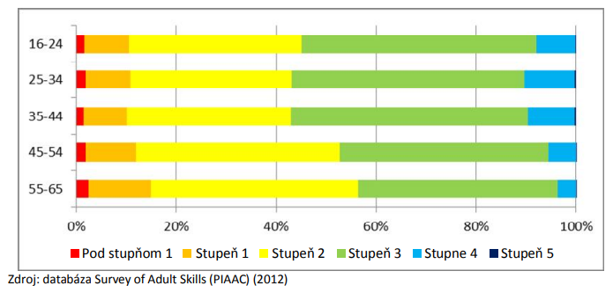

Graph 2 Mathematical literacy of five age groups in Slovakia (Bunčák et al, 2013, pp. 22-23)

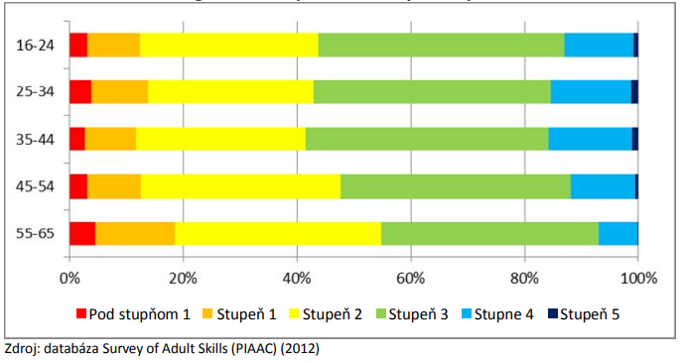

**Financial literacy** can be understood as the ability to deal effectively with finances in everyday situations. These include acquired knowledge and skills in managing own finances, domestic budget, managing the current and unplanned income and expenses, eliminating thieves, working to reduce own expenses, planning future expenses, getting acquainted with banking theory and also the ability to borrow money rationally. Slovak seniors are the group that is most at risk, the so-called income poverty. The biggest financial burden for them is the costs associated with housing as well as the increasing costs of health care and social services. A small qualitative study showed that three participants with secondary education had greater skills and abilities in the field of financial literacy, in comparison to a participant with basic education, who had almost no experience in financial matters (Směřičková, 2018).

In Slovakia, the HLS19 data collection were performed from June 22 to September 14, 2020. Across all participating countries, about 40 % of the respondents have a “sufficient” level of HL and about 15% an “excellent” level (Graph 3). On the other hand, about 33% have a “problematic” level of health literacy and 13% an “inadequate” level. The levels varied by country (The HLS19, 2021, pp. 106-107):

* “inadequate” General HL between 4% (AT) and 27% (BE), 23% (SK),
* “problematic” General HL between 18% (SI) and 48% (DE), 36% (SK),
* “sufficient” General HL between 23% (DE) and 65% (PT), 31% (SK),
* “excellent” General HL between 5% (DE and PT) and 29% (IE), 10% (SK).

Graph 3 Percentage of respondents by categorical level of General HL as measured by the HLS19-Q12, for each country and the mean for all countries (The HLS19, 2021, pp. 106-107).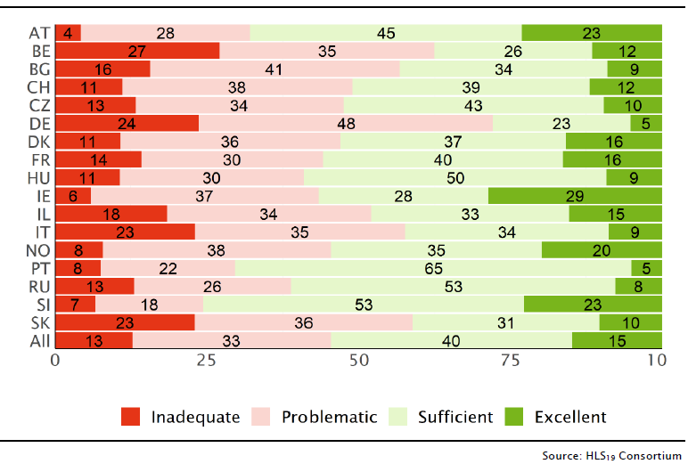

The highest average difference between the “subpopulation means” and the country’s GEN-HL mean score was found for the subpopulation with “poor self-perceived health”, which is -13.8 below the total mean (62.2 vs. 76.0, ranging from -5.2 (CZ) to -27.4 (PT), -19.6 (SK)). The “financially deprived” subpopulation showed a difference of -8.2 points (ranging from +0.7 (BE) to -14.4 (BG), -10.6 (SK)), and the respondents reporting “low level in society/low social status” of -7.9 points (ranging from -2.0 (AT) to -17.9 (BG), -16.7 (SK)). The lowest average difference was found for respondents with one or more reported “long-term illnesses or health problems” at -2.6 (varying from -0.3 (CZ) to -7.2 (PT), -2.9 (SK)). Average differences for the other defined subgroups were -6.3 for “low education” (ranging from +0.6 (CZ) to -21.7 (RU), -20.4 (SK)), -4.5 for “six or more contacts with a GP/family doctor” within one year (ranging from -06 (CZ) to -11.5 (BG, SK)), and -4.9 for respondents “aged 76 or older” (ranging from +6.6 (CZ) to -24.4 (PT), -22.4 (SK)) (Table 3, The HLS19, 2021).

Table 3 Differences in mean HLS19-Q12 scores between the country sample and selected vulnerable subpopulations, for each country and the mean for all countries (equally weighted)

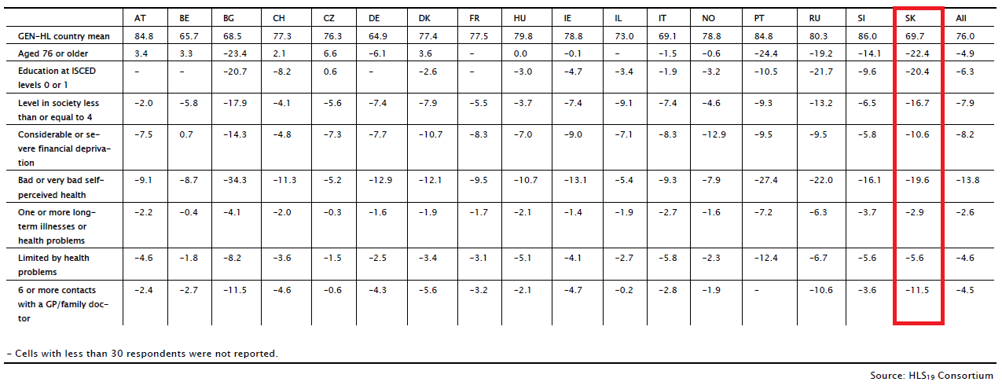

Table 4 Spearman correlations (ρ) between GEN-HL and selected determinants, for each country and for all countries (equally weighted)

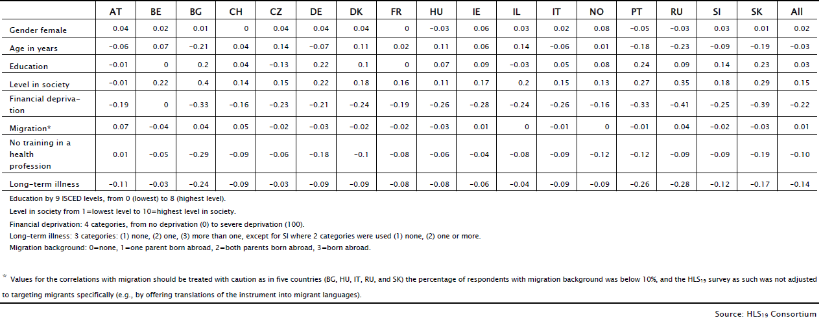

In most participating countries, the association of General HL with age was nonlinear in different ways (Graph 4). Therefore, the overall association of age with General HL for all countries is low with a Spearman coefficient of ρ=-0.03 (Table 4, Graph 4). There are countries with an expected negative correlation, ranging from ρ=-0.06 (AT) to ρ=-0.23 (RU) as well as countries with an unexpected somewhat lower positive correlation, ranging from ρ=0.01(NO) to ρ=0.11 (DK, HU). For Slovakia it was ρ=-0.19 (The HLS19, 2021).

Graph 4 Means of GEN-HL scores by age in seven groups, for each country and for all countries (equally weighted)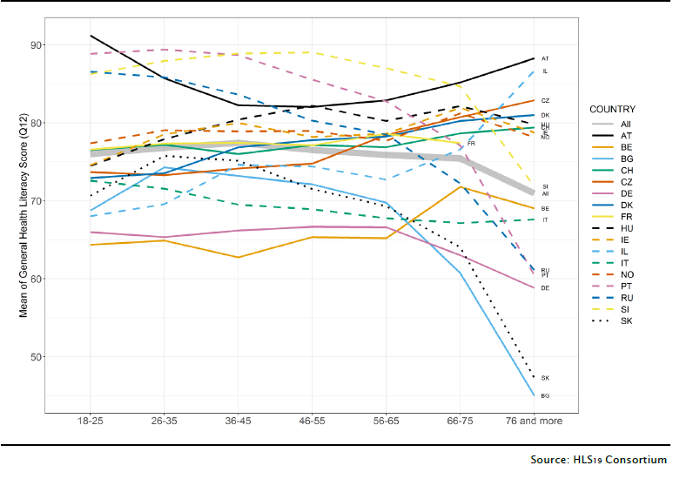

*Main gaps and issues identified by the latest studies (i.e. individual and system factors)*

The Slovak survey in 2014-2015 found significantly lower HL across all domains among those with lower education, lower scores for unemployed in the domain 4, and for those with 3 chronic diseases in the domain 8 (Kolarcik et al, 2017). However, these findings were for whole adult sample with only 3.7 % of people over 65.

The literature review for the years 2011-2019 focused on the impact of socio-demographic characteristics of seniors on the level of their health literacy. The results of the analysis 12 out of the total number of 43 studies found showed that age, education, financial and social status significantly affect the level of health literacy of seniors (Beňadiková & Bóriková, 2020). In Slovak pilot study carried out in 2020-2021, an adequate literacy levels were achieved by youngest seniors aged 65-74 (n = 17), men (n=8), with secondary education (n = 11), living in the city (n = 18) and in marriage (n = 13) (Beňadiková & Bóriková, 2021).

The systematic review focused on the impact of HL on medication use in the elderly over 60 years of age identified 5 the most relevant studies (out of 6881 found). Their findings were related with the following areas: number of medications in the senior's treatment process, adherence to drug use instructions, understanding of drug attributes and the treatment process, as well as the impact of healthcare providers on the level of understanding drug characteristics and the treatment process (Čarnogurská, 2021, s. 36-53).

One of the first studies oriented on the HL of family carers of older people living with dementia found significant associations between the HL and carer burden, HL and health-related quality of life, and between HL and time spent on care (Haikio et al, 2020). Due to the fact that even in Slovakia, long-term care for the elderly is provided primarily in the home environment, some family carers (such as partners, friends) represent an age-specific target group for the field of health literacy of seniors.

At the same time, Slovakia is copying the trend in which the participation of adults in education increases with the level of education (which is also related to the fact that education takes place mainly in companies) and decreases with age (due to declining motivation) (Graph 5, MŠVVaŠ SR, 2021, p. 10).

Graph 5 Adult participation in education by age in %, 2019

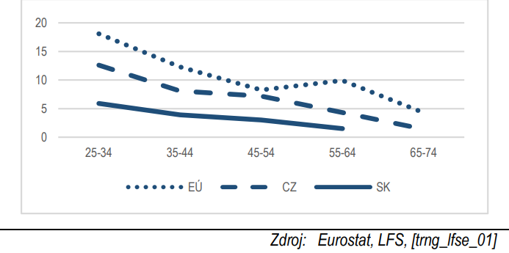

* National Strategy Path on Diseases Prevention, Health Protection, and Health Promotion: Priority Areas and Strategic Objectives

Diseases Prevention, Health Protection, and Health Promotion are incorporated in the **Strategic framework for health for 2014-2030** (Strategický rámec starostlivosti o zdravie 2014-2030) approved by Slovak Government on December, 18th 2013 (Vláda SR, 2013). It constitutes main document that determines the medium and long-term direction of Slovak health policy. In this strategic document four priority areas are identified:

1. Investing in own health throughout a life-course and empowering people;

2. Tackling the major health challenges in the region: non-communicable and communicable diseases;

3. Strengthening people-centered health services, public health capacity and emergency preparedness, surveillance and response; and

4. Formation of healthy communities and supporting environment for the health of people.

In relation to the priority area 1, the framework declares that, „Health promotion should already begin during pregnancy and early childhood, and later at elderly humans, by which we reach the set objective of active ageing and increase of longevity. Healthy and active ageing of population is a policy priority and important research priority. Health promotion programmes based on the principles of population involvement in activities strengthening their mental and physical capacity present the individual and social benefit (creating better conditions for healthy lifestyles, improving health literacy, selfsupport, etc.). A major problem in prevention and treatment of mental diseases is social isolation of seniors (living alone, respectively in social services centers), their sense of being life and social burden for families and society.”

With regard to the priority area 2, there is stressed: “It will be important to develop health literacy among young people, up to integration of efforts in developing mental and physical health as well as education to responsible paternhood. Among the seniors, will be very important the engagement in initiatives aimed at active and healthy ageing contributing to a healthier and better life of people in retirement categories and to their long-term self-support.”

The strategic objectives are presented for three health areas:

1. Public health;

2. Integrated outpatient healthcare; and

3. Inpatient healthcare.

The purpose of the **National Health Promotion Program** (NPPZ) is to promote health for all with aim to achieve a full life during the individual life stages of each citizen. The NPPZ is based on the policy of the World Health Organization (WHO), as well as on the strategic health policy framework and the Program Statement of the Government of the SR. The updated NPPZ is in line with the existing programs and action plans in the health sector and the Agenda 2030. Its aim is to improve the health status of the population of the SR, by increasing the level of health awareness and health promotion in the following areas (ÚVZ SR, 2021):

A. Preventive measures aimed primarily at promoting a healthy lifestyle style

1. Nutrition and diet

2. Physical activity

3. Tobacco, alcohol, drugs

4. Mental health promotion

5. Healthy working and living conditions

a. Work environment

b. Environment

B. Preventive measures aimed at preventing the prevalence of infectious diseases

1. Raising awareness of the importance of vaccination to selected diseases

The expected outputs in terms of impacts of the NPPZ implementation include an increased (digital) health literacy (knowledge and attitudes) in the field of healthy lifestyle, diet and eating habits, and in relation to vaccination (ÚVZ SR, 2021).

The key legislative document linked to the above listed national strategies related to diseases prevention, health protection, and health promotion is the **Act No. 355/2007** Coll. on protection, promotion and development of public health and on change and amendment to some acts in wording of later regulations.

* **Existing and Developing Public Policies for increasing Health Literacy, special focus on their scope of action and impact on senior citizens’**

Given that the level of HL is closely linked to the general literacy, public policies aimed at increasing general literacy are an important prerequisite for increasing the health literacy. In this context, Slovakia has developed a **Strategy for Lifelong Learning and Counseling for the years 2021-2030** (MŠVVaŠ SR, 2021):

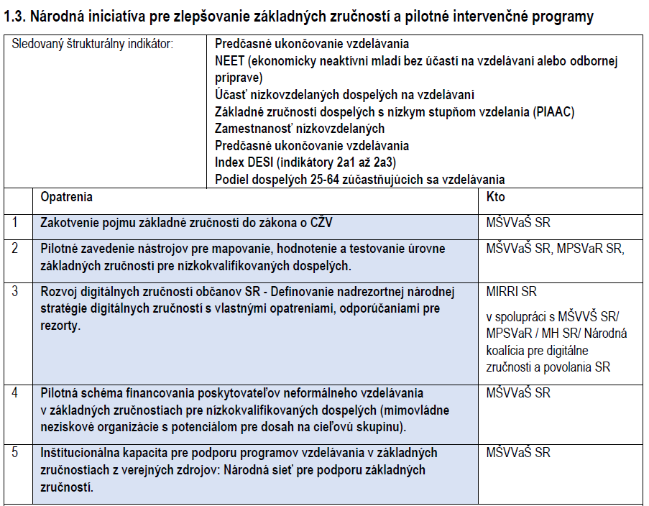

Although the target population for basic skills education is the general population, in terms of interventions and support from public funded programs, these are primarily low-skilled adults, which may or may not be associated with low levels of educational attainment, early school leavers, young people who are not employed or involved in further education, people with disabilities, migrants, seniors, people in prison and marginalized communities, or target groups who currently have a shortage of basic skills. For example, the COVID-19 crisis highlighted significant media literacy problems in a large part of the population, including university-educated adults (MŠVVaŠ SR, 2021, p. 22).

**National Active Aging Program for 2021-2030 (NPAS-II)** builds on previous experience with the implementation of policies and measures aimed at promoting active aging implemented under the NPAS-I (2014-2020). At the same time, it reflects the broader commitments that the Slovakia has currently defined in the document “Vision and Development Strategy of Slovakia until 2030” in the framework of the fulfillment of the UN Agenda 2030. The NPAS-II is not a duplicate of this document and in the area of active aging support it is elaborated in such a way that the fulfillment of individual goals, measures and obligations can be monitored and evaluated over time, or updated in accordance with the evolving social conditions and people's needs (Repková et al, 2020, p. 9; Skyba, 2017).

The document includes the support of general literacy of seniors in the strategic goal: Utilizing the potential of people for active aging as a basis for sustainable development of society through sustainable development of further education infrastructure (domain "Support of human resources in the life cycle"), fulfilled through two objectives and actions (MPSVR SR, 2021, p. 19):

* Objective 1: Legislation supporting lifelong learning

Action 1: *Incorporation of the issue of support for further education of older people into the forthcoming act on lifelong learning*

* Objective 2: Awareness of older people about the possibilities and conditions of further

education

Action 1: *Introduction of free counseling for older people on the possibilities and conditions of further education of people 50+ within the activities of the counseling center in client centers*

Seniors’ health literacy support is included in the strategic goal: Affordable and quality health care supporting the initial potential of people for active aging (area "Health care supporting active aging"), fulfilled through one objective and two measures (MPSVR SR, 2021, p. 22):

* Objective 2: Promoting active aging, a healthy lifestyle and overall health of older people

Action 2: *Improving the awareness and information of older people in the area*

*preventive vaccination through information and awareness-raising activities of regional public health authorities*

Action 3: *Implementation of educational and counseling activities of regional public health authorities on issues of support for active aging, healthy lifestyle and physical activities of older people performed in individual, group and collective form*

**II. National Context of Digital Health Literacy among Senior Citizens**

* **Broad scope of Digital Health (categories of tools and services)**

**Digital health tools** are digital services that provide users with general health information, health applications (treatment monitoring and follow-up), tools that allow people to stay in their homes (remote monitoring of the elderly), common health records, digital tools for health staff (secure messaging services, telemedicine, telephony of expertise) and general digital health information (EESC, 2019). A different division of digital tools is offered by the NHS Scotland, depending on whether these tools can help better self-care (self-management tools), help caring for others (caring tools), or facilitate access to health services (DHC, 2021). From the point of view of Slovakia, these innovations are also considered to be tools with the potential to ensure more efficient, better and safer healthcare in health system and better self-control over citizens' own health (MIRRI SR, 2019, p. 30)

* **Digital Health Literacy definition, general characteristics**

Digital information is becoming increasingly important in society. In the case of **digital health literacy**, it is not a question of finding health information, but rather of knowing where to look for it, whether accessible sources of information provide adequate and useful information and whether health information is reliable. Digital health literacy is an essential element for the successful implementation of e-Health.

**Digital literacy** is defined as "the ability to understand and use information in a variety of formats from a variety of sources presented through information and communication technologies". It is measured by the Digital Literacy Index, which consists of identifying several areas, such as hardware control (e.g. document printing, working with a PC); software control (e.g. working with a web browser, installing new programs); working with information (e.g. using internet banking, searching for information and services on the internet) and communication skills (e.g. sending text messages, e-mails, chatting, participating in discussion boards) (Skyba, 2017).

**Information literacy** is a comprehensive set of skills to understand and use the system of symbols dominant in a given culture for the development of one's own personality and community. The need for and demand for these skills varies across societies. In a technological society, this concept, in addition to knowledge of reading and writing, also includes the use of media and electronic resources (Novysedláková & Hudáková, 2012).

* **National statistics on ICT use: current number of households having access to the Internet, equipped with a computer, landlines, mobile lines, measured popularity of e-health resources, special focus on seniors**

One of the latest results are available from the survey on ICT in households and individuals realized by the Statistical Office of the Slovak Republic. The aim of survey was to determine the level of households’ access to Information and Communications Technologies as well as determine the level of knowledge and skills of the population and the ability to use these Technologies (ŠÚ SR, 2018). Similar results were reported also in 2020 - **men aged 55-74 used the internet the least**, specifically for social networking (34.7%) and instant messaging (34.9%) (Masárová et al, 2020).

Graph 6 shows use of the internet at home by individuals at the age of 16 to 74 in last 12 months from international point of view (the comparable data for all EU countries from ICT 2017 survey). In Slovakia 81% persons used internet at the age of 16 to 74 and there was almost reached average of EU. The similar level of the internet use reached countries, namely Hungary, Latvia, Spain, Czech Republic and Austria. The least use of the internet by individuals was in Bulgaria and in Romania, and the highest among population of Norway, Luxembourg and Holland.

In 2018 up to 80.8% of Slovak households had internet access at home. Compared to 2009 the increase by 18.6 perceptual points (p.p.) was recorded (Graph 7). In the households with the Internet access at home, most frequently used types of internet connection were the broadband connection (with increase from 85.7% in 2017 to 87.0% in 2018) and mobile broadband (with increase from 43.3% in 2017 to 54.5% in 2018). So called Dial-up connection or mobile narrowband connection used approximately 3.1 % households (Graph 8).

Graph 6 Use of the Internet in households (% of all households) in 2017 (Eurostat, 02.02.2018)

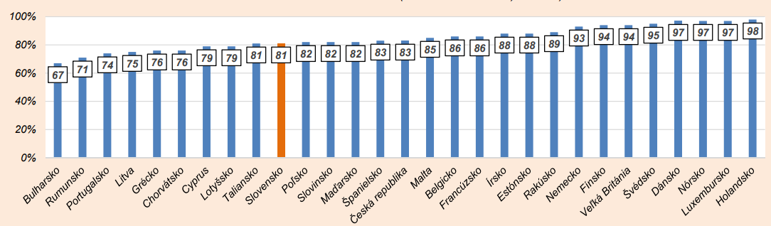

Graph 7 Access to the Internet at home 2009-2018 (share in total households in %)

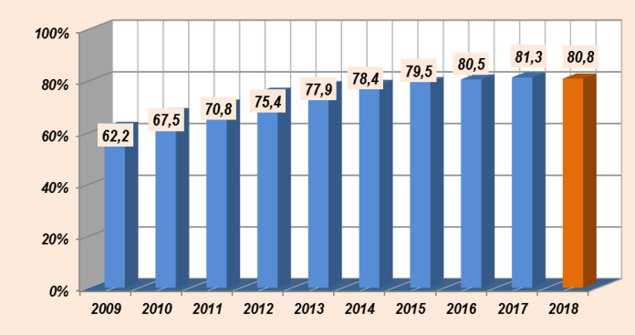

Graph 8 Types of the Internet connections used in households (in %)

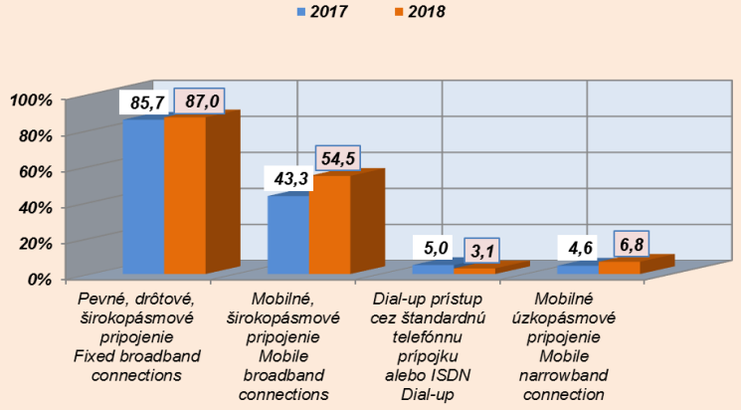

Graph 9 demonstrates use of Internet with individuals at the age of 16 up to 74 in the last 3 months from date of interview. In 2018 totally more than 80.4 % population at the age 16 to 74 used Internet in surveyed period, but with the lowest share at the age from 64 to 75 years (31.9%). The most frequent used devices for access to internet away of home or workplace were mobile phones and smartphones (Graph 10). However, the decrease was recorded in the age of 64 up to 75 (from 33.4% in 2017 to 22.6% in 2018).

Graph 9 Use of the Internet at home in the last 3 months by age (% in the whole population)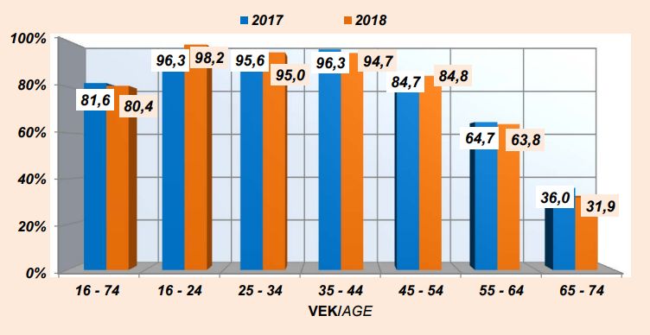

Graph 10 Use of mobile device to access the Internet (% in the whole population)

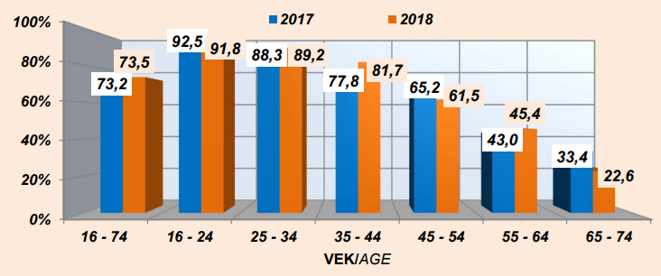

With regard to type of activities which people do on the Internet for private purposes in last three months, the most frequent activity was sending and receiving e-mail (almost 87.5 % in 2017 and 83.8 % in 2018), followed by participation in social networks, internet banking, and seeking information about health (61.1 % in 2017 and 60.7 % in 2018) (Graph 11).

Graph 11 Used of the Internet by type of private purpose (in %)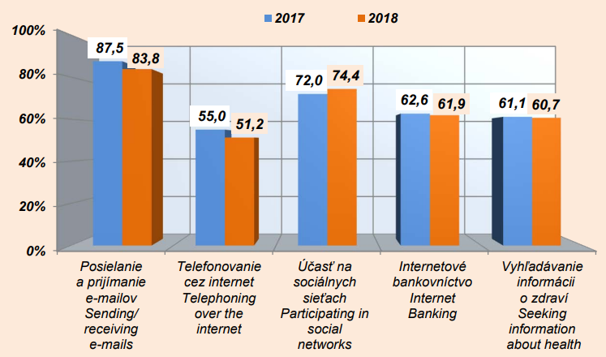

Using storage space for saving documents, pictures, music and video and so on via e.g. GoogleDrive, Dropbox was the lowest at age of 65 to 74. It can be linked to fact that with increasing age use of the Internet decreases in general (Graph 12). Also the prevalence of online purchase and ordering of goods or services in the last 12 months was the lowest and decreased at age of 65 to 74 (27.9% in 2017 to 18.0% in 2018) (Graph 13). The most frequently ordered goods was clothes and sports goods (almost 70 %) and drugs presented only 11.5% (ŠÚ SR, 2018).

Graph 12 Use of the internet for storage space by age (% in the whole population)

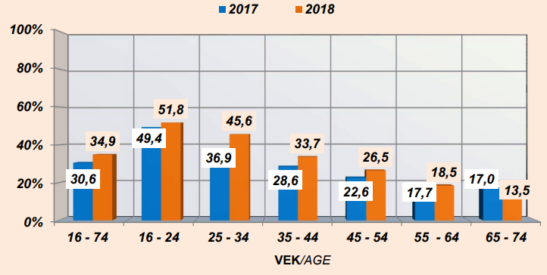

Graph 13 Purchase or ordering goods and services by age (% in the whole population)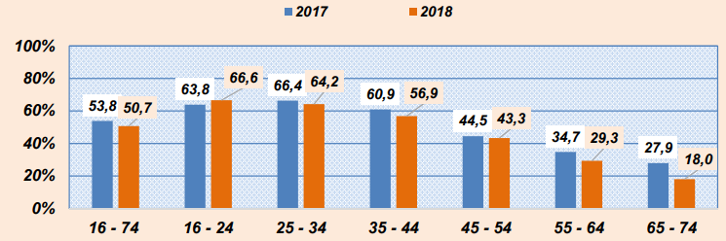

* National Digital Health Literacy overview: health literacy levels among seniors across years and status quo; main gaps and issues identified by the latest studies (i.e. individual and system factors)

In 2011-2012 Slovakia participated in the **Programme for the International Assessment of Adult Competencies** (PIAAC), the largest and most comprehensive representative survey on mapping the abilities and skills of adults. The first testing of adults aged 16-65 years included the ability to solve problems in a technically advanced environment. Slovakia was one of the countries with one of the highest shares - up to 21.7% of people had no experience with ICT or lacked the basic computer literacy needed to use ICT in everyday life (MŠVVaŠ SR, 2021, p. 30, Graph 14). In 2017, an online version of this tool named “Education and Skills Online” was pilot-tested, and the target group of seniors also participated in the testing through the Association of Universities of the Third Age (MPSVR SR, 2018).

Graph 14 PIAAC, 2012. https://piaac.nucem.sk/riesenie-problemov-ikt/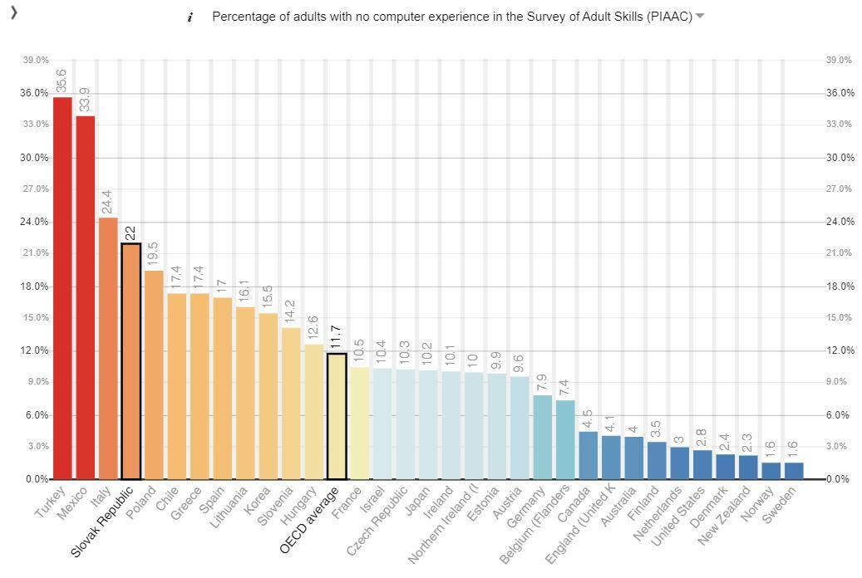

A more detailed assessment of the digital knowledge level of people in pre-senior (55-64 years) and senior (65-74 years) age is available through the regular internationally harmonized European Social Survey surveys (ESS). Digital skills assessment examines information skills, communication skills, troubleshooting and software skills. Based on the results of the ESS from 2017, the overall digital skills of persons aged 16-74 in Slovakia did not differ significantly from the EU28 average (higher than the basic level occurred in about a third of the population of the observed age category) (Repková et al, 2020, p. 12).

However, in the subgroup of elderly, there was a decline in the share of people with more than basic digital skills, and Slovakia lagged slightly behind the EU28 average in this respect. However, the results also showed that more than a third of the Slovak population aged 55-64 had not worked with the Internet in the last three months, and thus their overall digital skills could not be identified. In senior age, such behaviour accounted for almost two-thirds of the population, while in the EU28 it was less than half. At the age of over 75, only about a tenth of respondents said they had worked with the internet in the last three months (Repková et al, 2020, p. 12).

The share of the population aged 55-74 years who used the Internet daily for the last three months of the survey period increased in Slovakia during the years 2010-2019 - from 57% in 2010 to 80% in 2019. The growth rate was higher compared to the average of the EU28 countries, where the values increased in the observed period from 68% in 2010 to 81% in 2019. If the share of persons aged 55-74 years was observed, who in the last three months used the internet at least once a week (but not every day), the situation was different. Although the share of such a population in Slovakia decreased from 33% in 2010 to 17% in 2019, the findings were more favorable compared to the EU28 average, which accounted for 22% of the elderly population in 2010 and only 14% in 2019. (Repková et al, 2020, p. 11-12).

Adult skills measurements also point to lagging behind in solving problems in the IT environment. **The Digitization Index (DESI index)** in the human capital component includes an indicator for the basic skills rate in the population aged 16-74 years, where Slovakia is slightly below average (Graph 15). However, the acquisition of basic digital skills is essential for further education (e.g. online courses), effective involvement in the functioning of the state (e-government, e-health) and will limit further marginalization of vulnerable groups. (MŠVVaŠ SR, 2021, p. 9).

Graph 15 Proportion of population aged 16-74 with basic digital skills in %, 2019

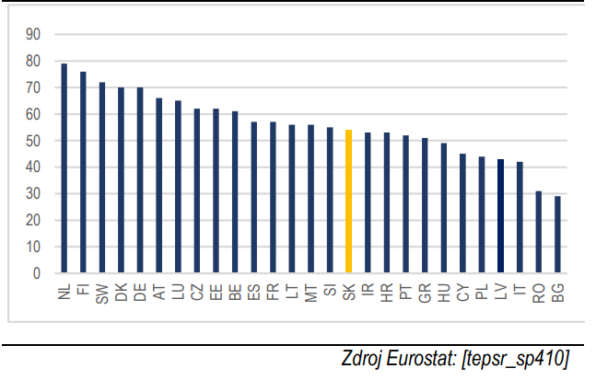

As part of the long-term analytical-monitoring project **Digital Literacy in Slovakia**, the Institute for Public Affairs carried out a series of representative sociological research in 2005, 2007, 2009, 2011, 2013, 2015, 2018 and 2020. Problems in mastering modern technology or complete resignation currently affect people over the age of 65 - up to 40% have difficulties with adapting and 52% do not adapt at all (Velšic, 2020, p. 5).

Progress in digital skills is increasing, especially with declining age, higher education, occupational demands and higher social status of the household (Graphs 16-18). The share of Internet users is above average, especially among respondents under the age of 54, high school and university graduates, mental workers, students, entrepreneurs and sole traders, people with higher income groups and city dwellers. On the other side of the spectrum are those who still resist the Internet for various reasons. There are above-average more of them among people over 55 years, respondents with basic or apprenticeship education, unskilled manual workers, unemployed, old-age pensioners, respondents from low-income households and respondents from small municipalities up to 2,000 populations (Velšic, 2020, p. 7-9).

Even in 2020, as in previous periods, the negative impact of computers and the Internet on society is not perceived uniformly by the entire population. Different social groups and categories of respondents respond differently to the problems generated by the informatization of society. Although in many cases the differences are only at the level of statistical error, in some cases they are quite logical given the social status and living situation of the respondents, such as for respondents over the age of 65 it is weakening the ability to communicate with other people (28%) and lack of physical activity (37%) (Velšic, 2020, p. 11).

Despite the fact that the balance of digital capabilities and skills of the population as a whole has improved in the seven-year perspective, significant differences were found between some social groups and environments in 2020 as well. An above-average share of the digital illiterate remained in less educated, lower qualified, economically inactive (pensioners, unemployed), socially weaker and rural groups (small municipalities with less than 1,000 inhabitants). Compared to 2013, therefore, there has been no significant shift in "digitally lagging" social environments (Graf 19). For example, the proportion of retirees with digital experience has increased by only 2 percentage points. It is similar for people with basic education, skilled manual workers, unemployed, households with the lowest income or inhabitants of small municipalities, where in the years 2013-2020 there was an increase of only 2-3 percentage points. This part of the population is failing to "catch up" and is on the brink of a digital divide (Velšic, 2020, p. 13).

The level of digital skills decreases with increasing age, and on the contrary increases with increasing level of education, sophistication, resp. occupational intensity and monthly household income (Graph 20). For example, while for people aged 14 to 44 we can talk about a high level of skills (digital literacy index 0.72 - 0.76 points), for 45 to 54-year-olds only about an average, and for people over 55 about deeply below average level (0.34 points). The most vulnerable group are people over the age of 65, who often only manage basic smartphone work such as making phone calls or sending SMS (only 0.13 points). The more skilled from them can work with a PC, searching for information on the Internet and e-mail communication, other activities and technologies are already causing them considerable problems (Velšic, 2020, p. 16).

Graph 16 Internet users by socio-demographic groups 2020 (18+), Digital Literacy in Slovakia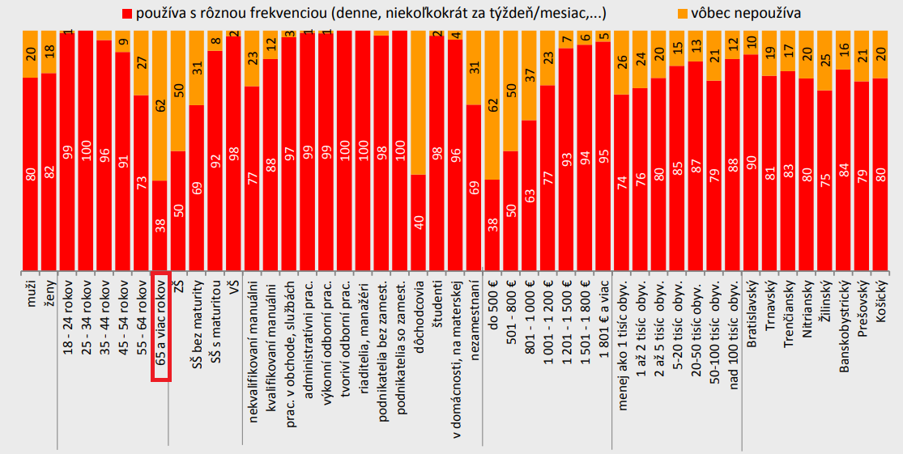

Graph 17 "Have you learned to use new hardware, software or services?" - by socio-demographic groups (14+), Digital Literacy in Slovakia

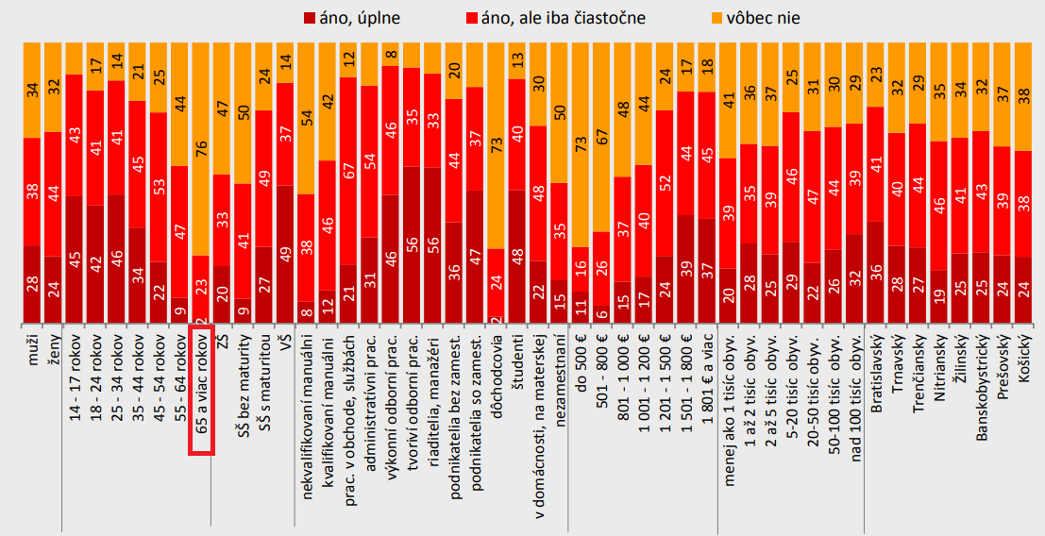

Graph 18 "Have you improved in what you have not mastered?" - according to socio-demographic groups (14+), Digital Literacy in Slovakia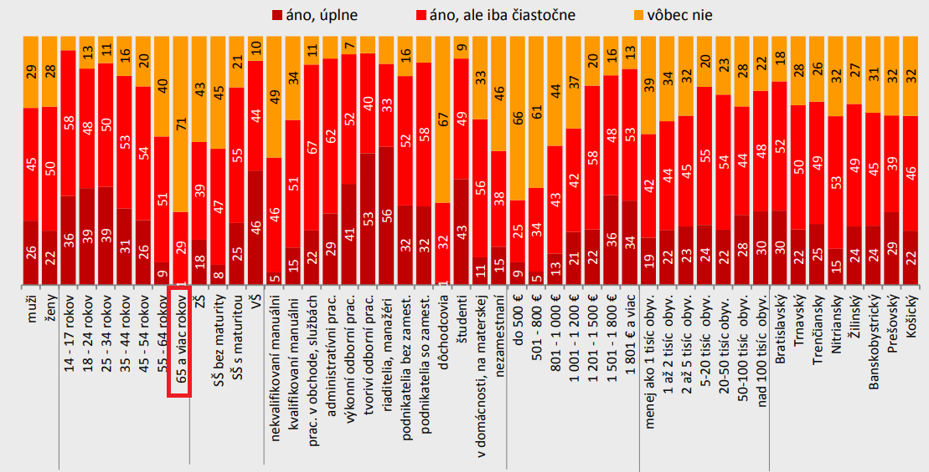

Graph 19 Digital literacy by socio-demographic groups - 2020 (14+), Digital Literacy in Slovakia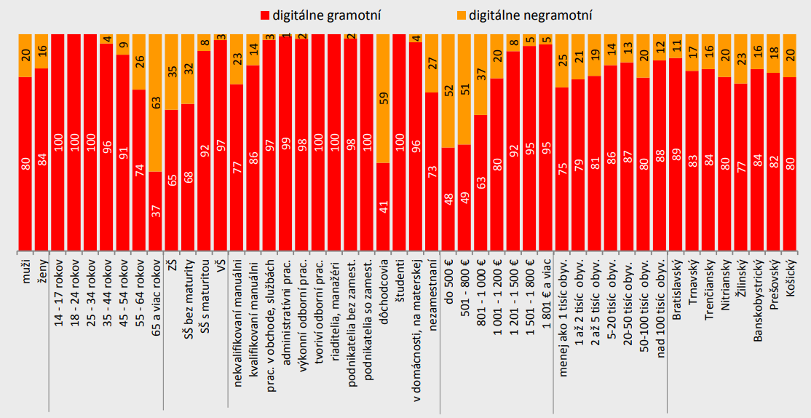

Graph 20 Digital literacy level by socio-demographic groups - 2020 (14+), (indices in points, average SR - 0.53 points), Digital Literacy in Slovakia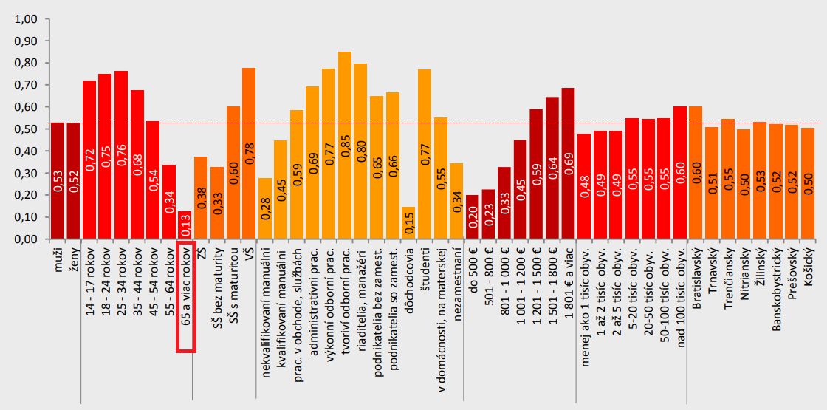

Regarding online activities in the field of health, the highest share of people using the Internet in the last 3 months to search for health-related information were Slovak seniors aged 65 to 74 years (65.5%), who were also in 3rd place for making an appointment with a practitioner via a website or apps (10.6%) (SO SR, 2018).

The above presented **HLS19** aimed also at development of new instruments to measure Digital HL, Communicative HL with physicians in healthcare, Navigational HL, Vaccination HL, and the Costs and Economics of HL, namely, respectively, the HLS19-DIGI, the HLS19-COM-P-Q11 (long form) and HLS19-COM-P-Q6 (short form), the HLS19-NAV, the HLS19-VAC, and an item set to measure HL and health-related quality of life as a mediator for health costs (The HLS19, 2021).

Of a sample of 485 seniors validated by age, gender, region, and degree of urbanization, most reported having searched for information on health or specific medical topics. In identifying the sources from which they sought the latest health information, 26% of seniors consulted a health professional, 26% obtained information from printed materials such as newspapers, leaflets or books, and 21% preferred information from their surroundings (family or friends). Furthermore, they drew less information from the digital sources or alternative healers (Graph 21). Of the seniors who reported they used the digital environment to obtain health information, more than half visited websites and more than a third watched social networks and discussion forums. Digitally-skilled seniors also reported using electronic communications with their healthcare provider and a mhealth apps on a smartphone (ÚVZ SR, 2021).

However, as many as 74% of seniors said it was difficult for them to assess the pros and cons of different treatment options. For 67% of seniors, it was difficult to assess whether the information on health risks presented in the media is credible. For more than half of the seniors, it was difficult to decide how to protect themselves from the disease according to information from the media. For most of them, it was easier to understand the health advice from family and friends (ÚVZ SR, 2021).

Graph 21 Sources of health-related information in Slovak seniors (HLS19)

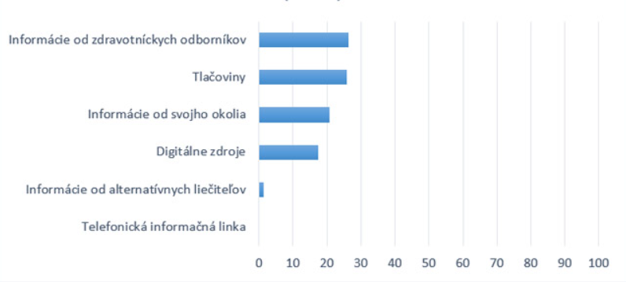

* **National promotion and use of ICT tools and techniques in accessing health information and services**

*General support policies*

Strengthening the potential of seniors in increasing their digital skills (digital literacy) is supported by adopted national documents such as the "Strategy for Digital Transformation of Slovakia 2030" and its "Action Plan for 2019-2022" or in the establishment of the "National Coalition for Digital Skills and Professions" (2017). Awareness-raising and education of seniors are defined not only as prerequisites for their social participation, but also as tools for their legal protection (e.g. against fraud and unfair practices, ill-treatment or increasing resilience to various crisis situations, e.g. with regard to the COVID-19 pandemics).

In the context of the long-term horizon, the **2030 Digital Transformation Strategy for Slovakia** outlines following expected priority areas that are follow ups and extensions of areas for short-term horizon: I. Innovative digital and data economy; II. Educated, healthy and secure society; III. Modern and efficient public administration, IV. Smart territorial development; and V. High-quality science, research and world-class innovations (MIRRI SR, 2019, p. 5). The intention of the Strategy is to implement real innovations with a potentially global impact which also contribute to meeting priorities of Slovakia in the field of sustainable development, defined in 2030 Agenda for Sustainable Development. In relation to strengthening the seniors’ digital health literacy, the intentions of the digital transformation in education, health care and social policy sectors are most important (Table 5).

Among the long-term priorities within the priority area II. Educated, healthy and secure society, two long-term priorities might be consider closely related to the seniors’ digital health literacy national promotion (MIRRI SR, 2019, p. 55-56):

II. Develop a system for providing training, courses, lifelong and formal education, retraining and other forms of special training to improve advanced digital skills

* Prepare a draft digital skills prediction for Slovakia as a basis for the development of the lifelong learning programmes, e.g. also on the basis of the relevant information from the national Labour Market Forecasting in the Slovak Republic II project, and the national Sector-Driven Innovation project;
* Prepare a call for the demand-driven projects to develop and implement the long-term specialized lifelong learning courses in the advanced digital skills according to DEP;
* Support the existing digital literacy-improving projects, increase women’s share in IT, facilitate collaboration between the academic, private and public sectors, and/or representation of the digital industry as a whole; and
* Prepare a support system for the civil society organizations that will assist in the education and use of ICT, the development of critical thinking and analytic skills, and perform the task of permanent supervision of the personal data management.

IV. Promoting the introduction of innovations in the health sector

* Reorient the healthcare system so that, in addition to providing healthcare, it also focuses on the protection and promotion of well-being;
* Establish a comprehensive health impact assessment and digitize the public health with the data science methods;
* Introduce the digital healthcare and personal assistants to promote healthy lifestyles, diagnostics, chronic disease management, and the like; Create a framework for a personalized mobile medicine (app-market) and equip each patient with a personal assistant by data use and further development of the National Health Information System (national eHealth);
* Encourage the deployment of digital innovations in clinical processes; and
* Further develop the health record sharing system − especially in the field of image information from examinations.

The **Action Plan for the Digital Transformation of Slovakia for 2019-2022** is based and directly follows up the 2030 Digital Transformation Strategy for Slovakia. Its strategic objective is formulated as following: “We will support digital transformation of schools and education in order to improve the quality and preconditions for employments and acquisition of digital skills and competences necessary for the digital era”. It is composed of two themes: 1.1 Education and digital skills, 1.2 Modernization and opening of the labour market. The current time necessarily requires increasingly higher literacy of people in all age categories. Due to the fact that this trend will intensify it is necessary to improve educational processes and, above all, adjust them to the needs of the digital era. It applies to all levels of education of pupils and students as well as education of employees and further education of adults and seniors (MIRRI SR, 2019).

The planned projects include preparation of the analysis of the condition of digital skills and competences in Slovakia with a proposal of particular measures and setting up standards of digital literacy for citizens also by means of projects such as “Buď KOMPetentný – Zamestnaj sa!/Be COMPetent – Get a job!” and “eSMART.” The national standard of digital literacy for citizens will set digital competences necessary for the study, work and life for all groups of population – pupils, including pupils with special education needs, students, adult inhabitants in the productive age and seniors. The basic starting point to determine digital competences of citizens constitutes the **European Digital Competence Framework for Citizens** (MIRRI SR, 2019, p. 24).

Furthermore, above described **Strategy for Lifelong Learning and Counseling for the years 2021-2030** (see also p. 14)considers digital and media literacy to be an essential part of basic skills and includes it under the Measure 3: Development of digital skills of Slovak citizens - Defining a supra-ministerial national strategy of digital skills with its own measures, recommendations for ministries (MŠVVaŠ SR, 2021, p. 22).

Table 5 Intentions of the digital transformation related to strengthening the seniors’ digital health literacy (MIRRI SR, 2019, p. 35)

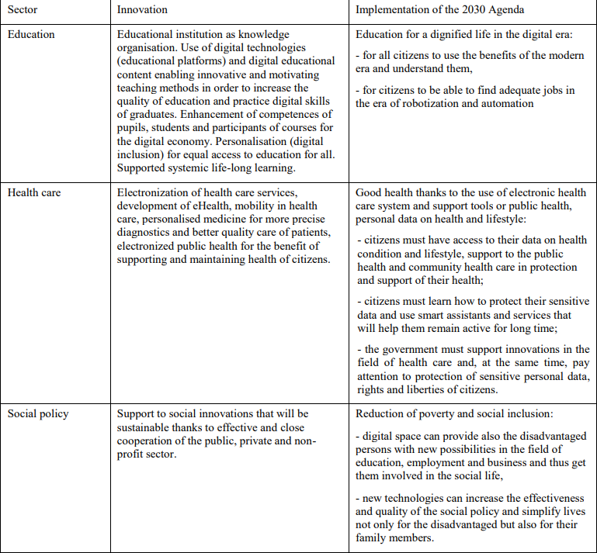

Finally, the **National Programme for Active Ageing for the years** **2021-2030** (p.19) includes the domain (area) on support for active aging "Support for human resources in the lifelong cycle" with strategic aim "Harnessing the potential of people for active aging as a basis for the sustainable development of society through the sustainable development of further education infrastructure".

Objective 3: Education aimed at seniors, strengthening their employment opportunities or staying in the labor market, accepting the key trends of the fourth industrial revolution;

*Action 1:* Support the design and implementation of training programs supporting key competences for lifelong learning with an emphasis on digital literacy, personal development and mental health in the context of labor market and employment requirements.

* National current trends/methods/approaches targeting seniors in relation to improving their digital health literacy level, focus on good practices and transferable trends/current methods

At present, further education of seniors in Slovakia including (D)HL is provided mainly by universities of the third age (UTV) at universities; academies of the third age, which operate mainly with the support of cities and municipalities; seniors' clubs within the Pensioners' Union in Slovakia; Regional Public Health Authorities; other further education institutions or NGOs. The key actors (stakeholders) and their actions in the field of seniors’ (digital)health literacy or related areas are presented in Table 6.

Table 6 The key actors in the field of seniors’ digital health literacy in Slovakia

| Stakeholder | Type of action | Area of action |
| --- | --- | --- |
| **Active Ageing Centre in Bratislava**  Centrum aktívneho starnutia v Bratislave  <https://www.active-ageing.eu/> | - project within the INTERREG V-A Slovakia - Austria | The aim of the project is to improve the conditions for effective provision of preventive care, health promotion and social inclusion of seniors in the cross-border region through several activities: information campaign, health education and training, research and building Active Aging Center (CAA) - **competence center for physical activity, prevention and health promotion for the elderly**. |
| **Active Ageing Centre in he Kosice region**  Centrum aktívneho starnutia v Košickom kraji  <https://www.viacarpatia.eu/projekty> | - project within the INTERREG V-A Slovakia - Hungary | The SK-HU Ambassadors project represents an innovative approach aimed primarily at improving the quality of life of seniors, supporting their health, physical activity and socialization. |
| **Association for the Protection of Patients' Rights of the SR**  Asociácia na ochranu práv pacientov v SR  <https://www.liekysrozumom.sk/> | - online platform  - individual conselling  - project | **Digital health literacy**  Providing online information on health through collaboration with health professionals and patients’ organisations; Medicines with Reason project |
| **Association of Universities of the Third Age in Slovakia**  Asociácia univerzít tretieho veku na Slovensku (17 ouf of 20)  <https://asutv.sk/> | - regular educational programs/activities  33/34/30 (2016-2018) | **Digital competencies 50+**  for complete beginners to specific topics such as working with Android, tablet, google applications, website creation. The content of education also has integrated cyber security topics. |
|  | - 1 specific course, 6 educational programs,  9 workshops (2017) - 13 UTVs, 440 seniors | **Financial literacy** |
| **Forum for Helping the Elderly - National Network**  Fórum pre pomoc starším - národná sieť  <https://www.forumseniorov.sk/> | - international project  16 courses per 2 hours in 3 organisations | **Digital general/health/financial literacy**  basics of working with a computer, tablet and smartphone; themes: leisure activities, health, communication with public and government institutions and protection of the rights of the elderly |
| **Institute for Prevention and Intervention**  Inštitút pre prevenciu a intervenciu  <https://www.ipisk.eu/> | - webinars for the public | **Digital health literacy**  education of the general public in the field of chronic disease prevention, hand hygiene, first aid, etc. |
| **National Coalition for Digital Skills and Professions of the Slovak Republic**  Národná koalícia pre digitálne zručnosti a povolania Slovenskej republiky  <https://itfitness.eu/sk/> | - IVF project  IT Fitness Test 2022  Visegrad Group | **Digital literacy**  The largest and most comprehensive test of ICT skills for the V4. Testing is focused mainly on students of primary and secondary schools to evaluate their readiness for further study or employment. |
| **Regional Public Health Authorities**  Regionálne úrady verejného zdravotníctva | - educational activities (one-time, regular, campaigns)  - counselling | **Health literacy**  Education in the field of health promotion and disease prevention in the elderly; interventions based on the health assessment in the Health Counseling Center |
| **Slovak patient**  Slovenský pacient  <https://slovenskypacient.sk/> | - online platform  - educational materials | **Digital health literacy**  Providing online information on health through collaboration with health professionals and patients’ organisations |

Based on experience from abroad, it is known that higher competencies, or a higher level of patient awareness will only apply if it can be relevant. Any program must therefore be designed so that the target social group is willing to change their behavior, i.e. so that one form of cultural capital can be supported by another. In this case, enlightenment (objectified capital) be interlinked to an interest in a healthy lifestyle (incorporated capital). Otherwise, the target groups lose interest for change (Janura, 2018, p. 133).

Investing in programmes that teach digital literacy skills to seniors can provide opportunities for lifelong learning and growth. Technologies can facilitate innovations that empower them to monitor and understand their own health, and track their trajectories of healthy ageing, enabling greater decision-making about their own lives (WHO, 2020).

| **Main Findings** | * In Slovakia, (digital) health literacy is a new public health research area with very limited data on (digital) health literacy of seniors. * In the area of seniors’ (digital) health literacy, Slovakia refers more to data from other countries and increases the awareness on the issue by presenting it in national language. * The growing interest in the (digital) health literacy research is observed more in nursing and public health than in other health professions. * Health literacy of seniors is partly incorporated in the strategic national documents. * There is a need to integrate health literacy as a cross-cutting theme in general reading, mathematics, financial and digital literacy projects for seniors. * There is a need for coordination and networking of literacy actors among seniors at local and regional level |
| --- | --- |

| **Sources** | Act No. 355/2007 Coll. *on protection, promotion and development of public health and on change and amendment to some acts in wording of later regulations* (Zákon č. 355/2007 Z. z. o ochrane, podpore a rozvoji verejného zdravia a o zmene a doplnení niektorých zákonov). <https://www.epi.sk/zz/2007-355>  Beňadiková, D., & Bóriková, I. (2020). Sociodemografické charakteristiky seniorskej populácie a ich vplyv na úroveň zdravotnej gramotnosti - literárny prehľad (Socio-demographic characteristics of the senior population and their impact on the level of health literacy - a literature review). *Prakt. Lék*., 100(3), 113-117.  <https://www.prolekare.cz/en/journals/general-practitioner/2020-3-10/sociodemograficke-charakteristiky-seniorskej-populacie-a-ich-vplyv-na-uroven-zdravotnej-gramotnosti-literarny-prehlad-123733>  Beňadiková, D., & Bóriková, I. (2021). Pilotná štúdia zdravotnej gramotnosti seniorskej populácie – Použitie nástroja newest vital sign (Pilot study of health literacy of the elderly population - Use of the newest vital sign tool). In *Reviewed abstracts from a scientific virtual conference XII. Trenčín Nursing Day* held on 11 November 2021, A1-A2.  <https://zl.tnuni.sk/fileadmin/Archiv/2021/2021-9.c.4/ZL_2021_9_4_13_Supplement.pdf>  Bunčák, J. et al. (2013). *Národná správa PIAAC Slovensko 2013 - Výskum kompetencií dospelých* (PIAAC National Report Slovakia 2013 - Research of adult competencies). Národný ústav celoživotného vzdelávania, Bratislava. ISBN 978-80-971503-1-0.  <https://epale.ec.europa.eu/sites/default/files/narodna_sprava_piaac_sk_2013.pdf>  Cepova, E. et al. (2018). Associations of multidimensional health literacy with reported oral health promoting behaviour among Slovak adults: a cross-sectional study. *BMC Oral Health* 18 (44). https://doi.org/ 10.1186/s12903-018-0506-6  Čarnogurská, M. (2021). Zdravotná gramotnosť pacientov o užívaní liekov, bakalárska práca. (Health literacy of patients about drug use, bachelor thesis). Slezská univerzita v Opave. FVP : Opava (66 p.)  https://is.slu.cz/th/kmju8/FVP_BP_21_Zdravotni_gramotnost_pacientu_o_uzivani_leku_Carnogurska_Martina.pdf  Čepová E. et al. (2017). Zdravotná gramotnosť, metóda jako zlepšiť zdravie populácie a jej využitie vo verejnom zdravotníctve (Health literacy, method as improve health population and exploitation in public health). Health and Social Work 12(1), 24-32.  http://www.zdravotnictvoasocialnapraca.sk/wp-content/uploads/ZaSP_Cislo_1_2017_SK.pdf  DHC. (2021) ‘Discover Digital: for your health and wellbeing’ Draft version 1.0. <https://www.alliance-scotland.org.uk/blog/resources/discover-digital-guide/>.  Dimunová, L. (2018a). Zdravotná gramotnosť v multidisciplinárnom kontexte (Health literacy in a multidisciplinary context). In Vansač, P. Barkasi, D. & Popovičová, M. eds. 2018. *Zborník zo IV. Medzinárodnej vedeckej konferencie Spôsoby prepojenia systému sociálnych služieb a zdravotnej starostlivosti na úrovni komunitných a pobytových služieb regionálneho charakteru* (Proceedings of IV. International scientific conference Ways of connecting the system of social services and health care at the level of community and residential services of a regional nature). 73-77. <https://www.prohuman.sk/files/Zborn%C3%ADk_Michalovce_2018.pdf>  Dimunová, L. (2018b). Zdravotná gramotnosť ako kľúčový determinant zdravia (Health literacy as a key health determinant). Vysoká škola zdravotníctva a sociálnej práce Sv. Alžbety, n.o. Detašované pracovisko bl. Sáry Salkaháziovej v Rožňave : Bratislava. 46-54 p. ISBN 978-80-8132-184-9. <https://www.danubiushotels.com/inc/opendoc.php?fn=/w/hd/Piestany/denose/4rocnik/AED_Zbornik_2018_.pdf>  EC. (2021). 2021 Long-Term Care Report - Trends, challenges and opportunities in an ageing society. Country profiles Volume II. Joint report prepared by the Social Protection Committee (SPC) and the European Commission (DG EMPL). ISBN 978-92-76-38219-5. DOI 10.2767/183997. Online: <https://op.europa.eu/en/publication-detail/-/publication/b39728e3-cd83-11eb-ac72-01aa75ed71a1>  EESC. (2019). *Stanovisko Európskeho hospodárskeho a sociálneho výboru – Digitálna zdravotná gramotnosť – zdravotná starostlivosť prispôsobená potrebám európskych občanov v čase demografických zmien (stanovisko z vlastnej iniciatívy)* (Opinion of the European Economic and Social Committee on ‘Digital health literacy — for citizen-friendly healthcare in Europe in times of demographic change’)  <https://op.europa.eu/sk/publication-detail/-/publication/e67f21e7-9f1d-11e9-9d01-01aa75ed71a1>  EU. (2021). 2021 *Long-Term Care Report - Trends, challenges and opportunities in an ageing society. Country profiles. Volume II.*  <https://ec.europa.eu/social/BlobServlet?docId=24080&langId=en>  Häikiö, K., Cloutier, D., & Rugkåsa, J. (2020). Is health literacy of family carers associated with carer burden, quality of life, and time spent on informal care for older persons living with dementia?. *PloS one*, 15(11), e0241982. <https://doi.org/10.1371/journal.pone.0241982>  Hulková, V. (2018). *ABeCeDa zdravotnej gramotnosti* (Health literacy alphabet). Vysoká škola zdravotníctva a sociálnej práce Sv. Alžbety, n.o. Detašované pracovisko bl. Sáry Salkaháziovej v Rožňave : Bratislava. 105-114 p. ISBN 978-80-8132-184-9.  <https://www.danubiushotels.com/inc/opendoc.php?fn=/w/hd/Piestany/denose/4rocnik/AED_Zbornik_2018_.pdf>  Janura, L. (2018). *Výzkum zdravotní gramotnosti ve střední Evropě* (Health Literacy in Central Europe). <https://relik.vse.cz/2018/download/pdf/202-Janura-Lukas-paper.pdf>  Kolarcik, P. et al. (2017). Structural properties and psychometric improvements of the Health Literacy Questionnaire in a Slovak population. *Int J Public Health*, 62, 591–604. <https://doi.org/10.1007/s00038-017-0945-x>  Masárová, J. et al. (2020). *Internet usage in households of the Slovak Republic.*  <https://doi.org/10.31410/EMAN.S.P.2020.153>  MIRRI SR. (2019). *Action plan for the digital transformation of Slovakia for 2019 – 2022. Action plan for transformation of Slovakia into a successful digital country and development of the digital single market.*  <https://www.mirri.gov.sk/wp-content/uploads/2019/10/AP-DT-English-Version-FINAL.pdf>  MPSVR SR. (2021). *Národné priority rozvoja sociálnych služieb na roky 2021-2030.* (National priorities for the development of social services for the years 2021-2030). Ministry of Labour, Social Affairs and Family of the Slovak Republic.  <https://www.employment.gov.sk/files/slovensky/rodina-socialna-pomoc/socialne-sluzby/nprss-fin.pdf>  MPSVR SR. (2018). *Správa o plnení úloh vyplývajúcich z Národného programu aktívneho starnutia na roky 2014 – 2020.* (Report on the fulfillment of tasks arising from the National Program for Active Aging for the years 2014 – 2020). Ministry of Labour, Social Affairs and Family of the Slovak Republic.  <https://www.employment.gov.sk/files/slovensky/ministerstvo/rada-vlady-sr-prava-seniorov/r2018-sprava-plneni-uloh-npas-r-2014-2020.pdf>  MŠVVaŠ SR. (2021). *Stratégia celoživotného vzdelávania a poradenstva na roky 2021 – 2030* (Lifelong learning and counseling strategy for the years 2021 – 2030). Ministry of Education. Science, Research and Sport of the Slovak Republic.  https://www.minedu.sk/data/att/22182.pdf  Novysedláková, M., & Hudáková, Z. (2012). Zdravotná gramotnosť pacienta ako edukačný problem (Patient health literacy as an educational problem). Fakulta zdravotníckych odborov PU v Prešove. s. 416-421. ISBN 978-80-555-0698-2.  https://www.pulib.sk/web/kniznica/elpub/dokument/dernarova6/subor/p14.pdf  Osborne, R.H., Batterham, R.W., Elsworth, G.R. et al. 2013. The grounded psychometric development and initial validation of the Health Literacy Questionnaire (HLQ). *BMC Public Health* 13, 658. <https://doi.org/10.1186/1471-2458-13-658>  Repková, K. et al. (2020). *NP aktívneho starnutia na roky 2021-2030 - analytická časť* (NP of active aging for the years 2021-2030 - analytical part). <https://ivpr.gov.sk/wp-content/uploads/2020/10/narodny_program_aktivneho_starnutia_repkova_2020.pdf>  Skyba, M. (2017). *Vplyv IKT na kvalitu života a aktívne starnutie seniorov a senio*riek (The Impact of ICT on Quality of Life and Active Aging of Seniors).  <https://www.pulib.sk/web/kniznica/elpub/dokument/Balogova11/subor/Skyba.pdf>  Vláda SR. (2013). *Strategický rámec starostlivosti o zdravie 2014-2030* (Strategic framework for health for 2014-2030). <https://www.health.gov.sk/?strategia-v-zdravotnictve>  Směřičková, P. (2018). *Finančná gramotnosť seniorov* (Financial literacy of the seniors).  https://www.pulib.sk/web/kniznica/elpub/dokument/Kvasnakova3/subor/Smerickova.pdf  ŠÚ SR. (2018). *Zisťovanie o využívaní informačných a komunikačných technológií v domácnostiach 2018* (Survey on Information and Communication Technologies Usage in Households 2018).  <https://slovak.statistics.sk/wps/wcm/connect/3fa87945-8bf1-47e0-a9d2-1451aee938f0/Zistovanie_o_vyuzivani_informacnych_a_komunikacnych_technologii_v_domacnostiach_2018.pdf?MOD=AJPERES&CACHEID=ROOTWORKSPACE>  The HLS19. (2021). The HLS19 Consortium of the WHO Action Network M-POHL. *International Report on the Methodology, Results, and Recommendations of the European Health Literacy Population Survey 2019-2021 (HLS19) of M-POHL.* Austrian National Public Health Institute: Vienna.  <https://m-pohl.net/sites/m-pohl.net/files/inline-files/HLS19%20International%20Report.pdf>  The HLS19. (2021) Annex. The HLS 19 Consortium of the WHO Action Network MPOHL. *International Report on the Methodology, Results, and Recommendations of the European Health Population Survey 2019 Vienna2021 (HLS 19) of MPOHL*. Austrian National Literacy e Public Health Institut : Vienna.  <https://m-pohl.net/sites/m-pohl.net/files/inline-files/Annex%20of%20the%20HLS19%20International%20Report.pdf>  ÚVZ SR. (2021) *Aktualizácia Národného programu podpory zdravia* (National Health Promotion Program (NPPZ). <https://rokovania.gov.sk/RVL/Material/26769/1>  Velšic, M. (2020). Digitálna gramotnosť na Slovensku 2020 (Digital literacy in Slovakia 2020). Inštitút pre verejné otázky: Bratislava. ISBN 978–80–89345–81-6.  <https://www.ivo.sk/buxus/docs//publikacie/subory/Digitalna_gramotnost_2020.pdf>  WHO. (2020). *Decade of healthy ageing: baseline report.*  <https://www.who.int/publications/i/item/9789240017900> |
| --- | --- |

*The project is co-financed by the Governments of Czechia, Hungary, Poland and Slovakia through Visegrad Grants from International Visegrad Fund. The mission of the fund is to advance ideas for sustainable regional cooperation in Central Europe.*